Hayley Mills Workshop
Saturday 18th October 2025
10am - 12.30pm

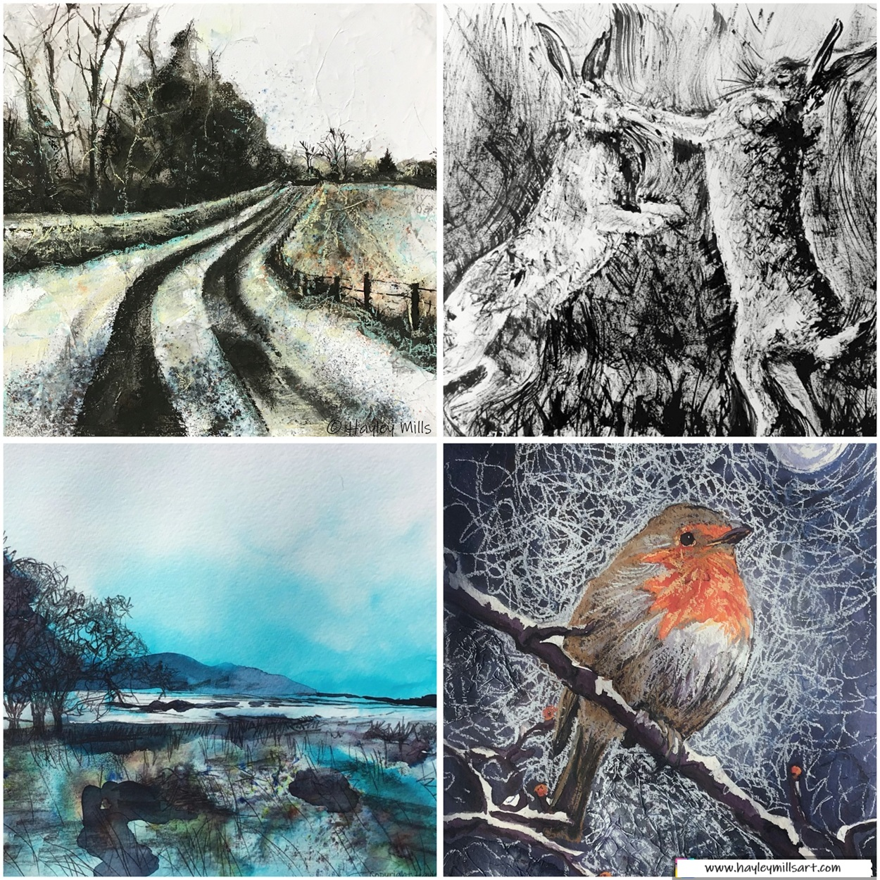

Hayley Mills Workshop
Saturday 18th October 2025
10am - 12.30pm
Dynamic Drawing Ink Workshop: Ink is a dynamic & versatile medium, in this session we will experiment with ink and drawing tools to create black and white dynamic drawings. We will do some warmup sketches and then do a more ‘formal’ piece of work. Though the focus will be black and white, some elements of colour can be brought in to create dynamic effect.
Source Material: Bring some real life things to draw for warmups, it’s good to bring a variety of options. These can also be used for a main piece too if you wish or you can bring a landscape or wildlife photo for a main piece if you prefer.
It's good to take time to consider your source material, somethings that will suit black and white drawing and painting and that inspires you as a person.
Art Materials to Bring: you can use a decent gsm normal cartridge paper for drawing with ink, but will need either a 220-270gsm white mixed media or smooth watercolour paper for ink painted work. Bring a drawing board, any ink pens you may have, any dipping/nib pens you may have, black india ink, kitchen roll, watercolour type brushes, water jars, hair dryer to dry off work as we go (more than one will be required so everyone doesn't have to wait), water spritzers for spraying water if you have them, coloured inks (any decent brand), graphite pencil for sketching out, rubber. I will also bring paper and art materials that can be used.
Protection: bring something to protect the table as ink can stain, also gloves if you don't want your hands to stain and clothes you don't mind getting ink on.
Break: there won’t be a formal break since there are only 2.5 hours, but you can grab a cuppa if you need one.
Photos: am hoping I might have permission to take some pictures here and there during the class, I use them only to show what happens in my workshops. If you don’t want me to take any pictures of you and your work please let me know.
You Tube: Here is a link to some videos of the outcomes of my teaching sessions, you’ll find an Ink Playlist, this will give you a feel for things:
Hayley Mills Art - YouTube
Any questions, happy to advise 😊. Looking forward to seeing everyone.
Best wishes,
Hayley.

www.hayleymillsart.com
www.instagram.com/hayleymillsart
www.facebook.com/hayleymillsart
Hayley Mills, MA
Member of Visual Arts Scotland, Society of Scottish Artists, The Art & Nature Collective, Scottish Artists Union & former Chair Open Studios North Fife.
The Studio, Monimail, Fife, KY15 7RJ.

