Dunfermline Art Club presents

a demonstration by Faye Alexander-MacLeod.
“This session will be a relaxed and informative demonstration of silk paint application, techniques, and colour mixing. The subject matter will be seascape and landscape. There will be lots of opportunity for questions and discussion throughout the demo. I will demonstrate a step-by-step approach from initial drawing, selecting composition, to application of silk paint to achieve a completed artwork.”  Faye Alexander-MacLeod  Faye, a fine art graduate, has spent many years working at Bishopbriggs Academy and Douglas Academy Milngavie, where she taught painting, art history, ceramics, and photography.  Faye draws and paints in an expressive style. She uses a variety of media including acrylic, watercolour, pen and ink, and silk paints. Faye’s inspiration and passion comes from early morning walks along the shore and harbour of Pittenweem, and the hills and landscapes of the west coast. Here she soaks up the atmosphere of her surroundings. The boats, nets and big vistas of the sea, and the imposing landscape of the west, continue to influence her subject matter. She now devotes all her time to producing artwork from her studio in Pittenweem, exhibitions at ENOS, the Pittenweem Arts Festival and the Lillie Art Gallery in Milngavie. |  | 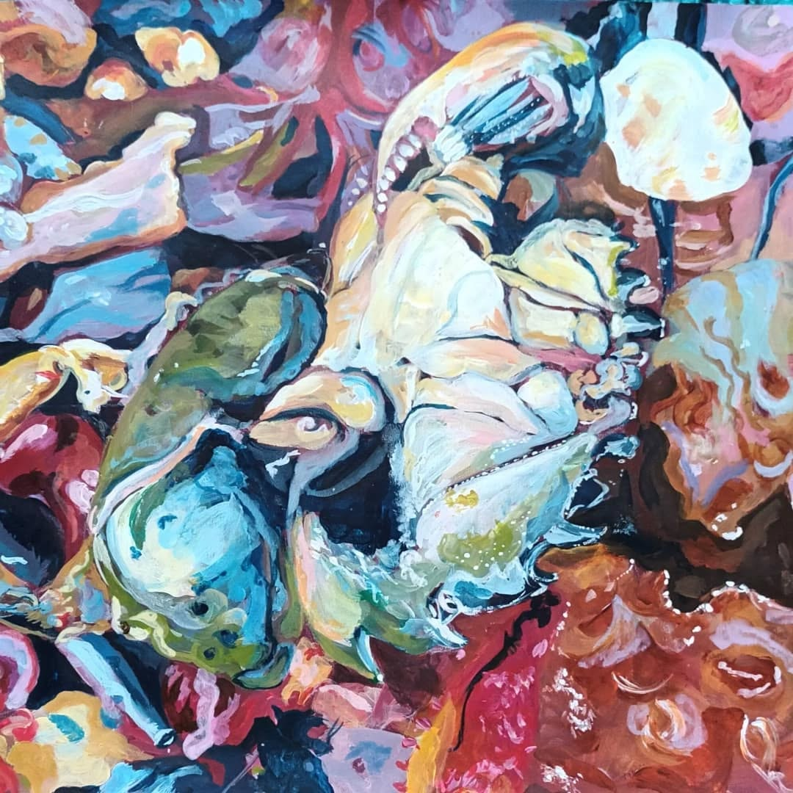  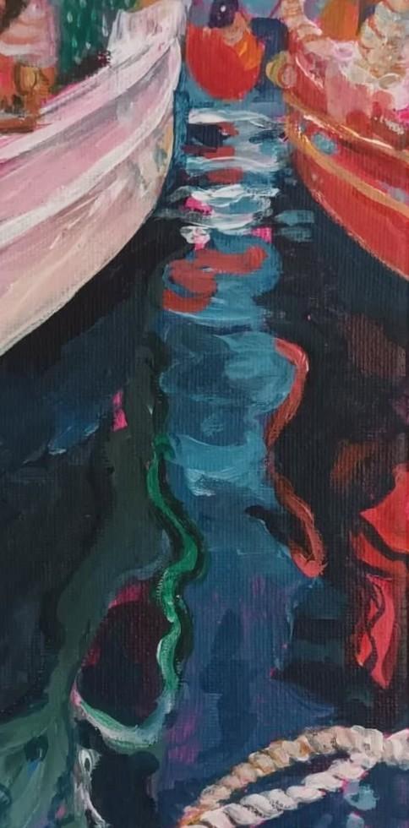  At 7PM on Tuesday 18th November, at Townhill Community Centre, Dunfermline, KY12OEN.  